3:
#include <iostream>
using namespace std;

int main() {
int i = 1, j = 0, k = 0;
try {
if (j == 0)
throw "Division by zero";
k = i / j;
cout << "in try" << endl;
cout << "k=" << k << endl;
} catch (const char* error) {
cout << "in except" << endl;
cout << "Error: " << error << endl;
cout << "k=" << k << endl;
}
return 0;
}

если делить на 0
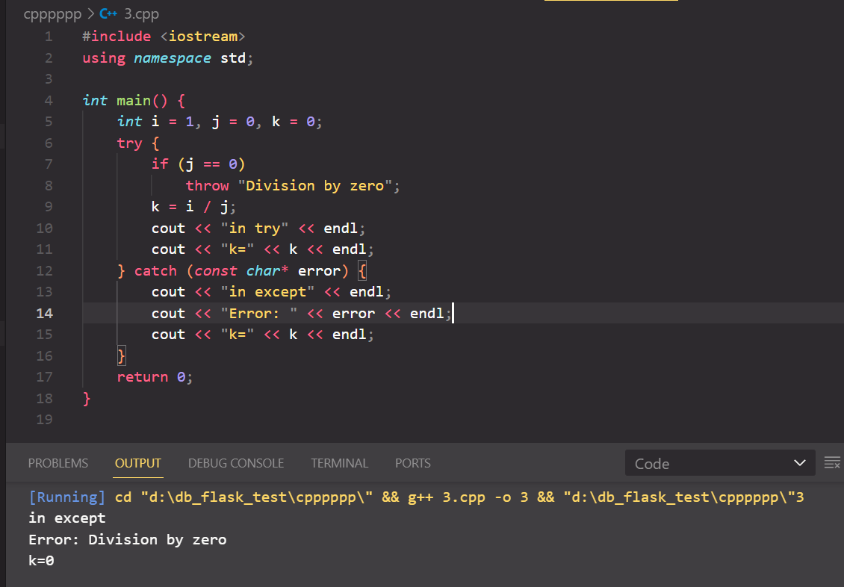

если делить не на 0
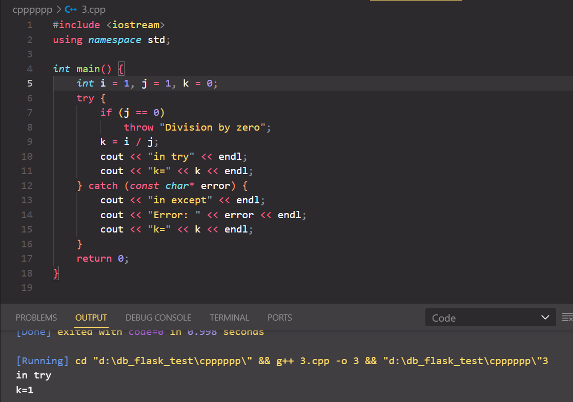

4:
#include <iostream>
#include <fstream>
#include <string>

int main() {
std::ifstream inputFile("MyFile.txt", std::ios::binary);
if (!inputFile.is_open()) {
std::cerr << "Failed to open input file." << std::endl;
return 1;
}

std::ofstream outputFile("MyOutputFile.txt", std::ios::binary | std::ios::trunc);
if (!outputFile.is_open()) {
std::cerr << "Failed to open output file." << std::endl;
return 1;
}

char ch;
while (inputFile.get(ch)) {
outputFile.put(ch);
}

inputFile.close();
outputFile.close();

std::cout << "File copied successfully." << std::endl;

return 0;
}

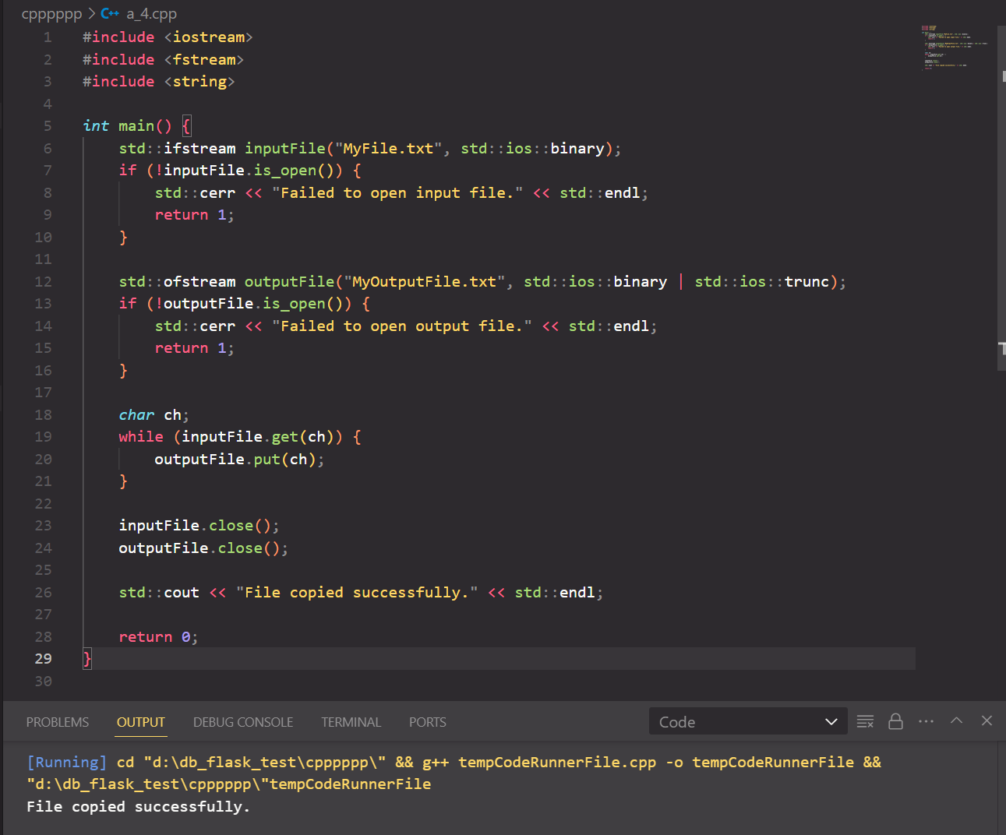



Симафоры:
#include <iostream>
#include <windows.h>
#include <vector>

constexpr int MAX_SEM_COUNT = 10;
constexpr int THREADCOUNT = 12;

HANDLE ghSemaphore;

DWORD WINAPI ThreadProc(LPVOID);

int main() {
std::vector<HANDLE> aThread(THREADCOUNT);
DWORD ThreadID;

ghSemaphore = CreateSemaphore(NULL, MAX_SEM_COUNT, MAX_SEM_COUNT, NULL);
if (ghSemaphore == NULL) {
std::cerr << "CreateSemaphore error: " << GetLastError() << std::endl;
return 1;
}

for (int i = 0; i < THREADCOUNT; i++) {
aThread[i] = CreateThread(NULL, 0, ThreadProc, NULL, 0, &ThreadID);
if (aThread[i] == NULL) {
std::cerr << "CreateThread error: " << GetLastError() << std::endl;
return 1;
}
}

WaitForMultipleObjects(THREADCOUNT, aThread.data(), TRUE, INFINITE);

for (auto& thread : aThread)
CloseHandle(thread);
CloseHandle(ghSemaphore);

return 0;
}

DWORD WINAPI ThreadProc(LPVOID lpParam) {
UNREFERENCED_PARAMETER(lpParam);

DWORD dwWaitResult;
bool bContinue = true;

while (bContinue) {
dwWaitResult = WaitForSingleObject(ghSemaphore, INFINITE);

switch (dwWaitResult) {
case WAIT_OBJECT_0:
std::cout << "Thread " << GetCurrentThreadId() << ": wait succeeded" << std::endl;
bContinue = false;
Sleep(5);
if (!ReleaseSemaphore(ghSemaphore, 1, NULL)) {
std::cerr << "ReleaseSemaphore error: " << GetLastError() << std::endl;
}
break;
default:
std::cerr << "WaitForSingleObject error: " << GetLastError() << std::endl;
break;
}
}
return TRUE;
}

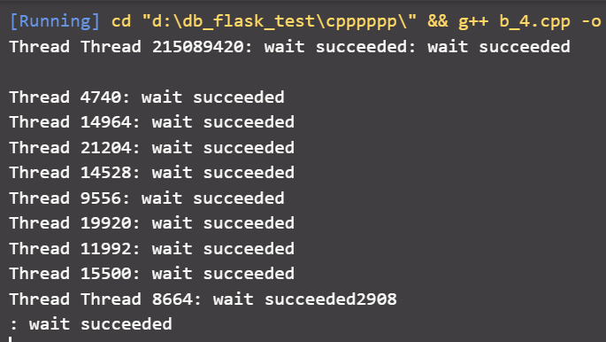

Mutex:
#include <iostream>
#include <windows.h>
#include <vector>

constexpr int THREADCOUNT = 2;

HANDLE ghMutex;

DWORD WINAPI WriteToDatabase(LPVOID);

void Cleanup() {
if (ghMutex != NULL)
CloseHandle(ghMutex);
}

int main() {
std::vector<HANDLE> aThread(THREADCOUNT);
DWORD ThreadID;

ghMutex = CreateMutex(NULL, FALSE, NULL);
if (ghMutex == NULL) {
std::cerr << "CreateMutex error: " << GetLastError() << std::endl;
Cleanup();
return 1;
}

for (int i = 0; i < THREADCOUNT; i++) {
aThread[i] = CreateThread(NULL, 0, WriteToDatabase, NULL, 0, &ThreadID);
if (aThread[i] == NULL) {
std::cerr << "CreateThread error: " << GetLastError() << std::endl;
Cleanup();
return 1;
}
}

WaitForMultipleObjects(THREADCOUNT, aThread.data(), TRUE, INFINITE);

for (auto& thread : aThread) {
CloseHandle(thread);
}
Cleanup();

return 0;
}

DWORD WINAPI WriteToDatabase(LPVOID lpParam) {
UNREFERENCED_PARAMETER(lpParam);

DWORD dwCount = 0;
DWORD dwWaitResult;

while (dwCount < 20) {
dwWaitResult = WaitForSingleObject(ghMutex, INFINITE);

switch (dwWaitResult) {
case WAIT_OBJECT_0:
try {
std::cout << "Thread " << GetCurrentThreadId() << " writing to database..." << std::endl;
dwCount++;
} catch (...) {
std::cerr << "Exception occurred while writing to database." << std::endl;
}
if (!ReleaseMutex(ghMutex)) {
std::cerr << "ReleaseMutex error: " << GetLastError() << std::endl;
}
break;
case WAIT_ABANDONED:
std::cerr << "Wait for mutex abandoned." << std::endl;
return FALSE;
}
}
return TRUE;
}

